Practice Queries -3

1. To display DCODE and DESCRIPTION of each dress in ascending order
of DCODE.

select Dcode, Descriptions from Dress order by Dcode asc;
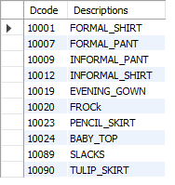
2. To display the details of all the dresses which have LAUNCHDATE in
between 05-DEC-07 and 20-JUN-08 (inclusive of both the dates).

select * from Dress where LaunchDate between '2007-12-05' and '2008-06-20';
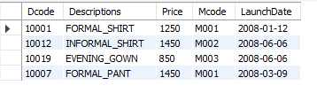
3. To display the average PRICE of all the dresses which are made of
material with MCODE as M003

select avg(Price) from Dress where Mcode = "M003";
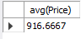

4. To display material-wise highest and lowest price of dresses from
DRESS table. (Display MCODE of each dress along with highest and
lowest price)

select Mcode, max(Price), min(Price) from Dress group by Mcode;
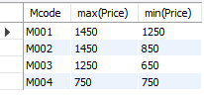
- To display total price for Terelene

select sum(Price) from Dress d inner join Material m on d.Mcode = m.Mcode where m.Type_s = "Terelene";
select sum(Price) from Dress where Mcode = "M001";
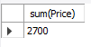
- To display DESCRIPTION, TYPE with PRICE more than 1250;

select Descriptions,Type_s, Price from Dress d inner join Material m on d.Mcode = m.Mcode where d.Price >1250;
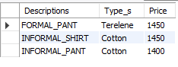
select Descriptions,Type_s, Price from Dress d inner join Material m on d.Mcode = m.Mcode where d.Price >=1250;
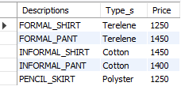
7. To display the maximum code from the material

select max(Mcode) from Material;
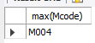
- To display number of unique dress price

select count(distinct(Price)) from Dress;
